Green Words  Green words are words which your son/daughter will be able to ‘go ahead’ and read as they are made up of the speed sounds that s/he will have learnt.  Set 1: starting point for the RWI program. The words follow the children progress as they learn and use the new sounds  Set 2: these words introduce the children to the sounds ay, ee, igh, ow, oo, oo, ar, igh, oy and ir.  Set 3: more independent and confident readers are introduced to these sounds which helps them complete the Read Write Inc program.  Red Words  These are words that are unable to be sounded out and so are irregular (common exception words). Children simply have to learn to recognize, read and spell these words as they cannot be sounded out using any sort of phonics strategy.  Examples of Red Words:  I the my you  said your of no  what were some there  brother their many does  [Company Name]  [Street Address]  [City, ST ZIP Code] |  |  | [Company Name]  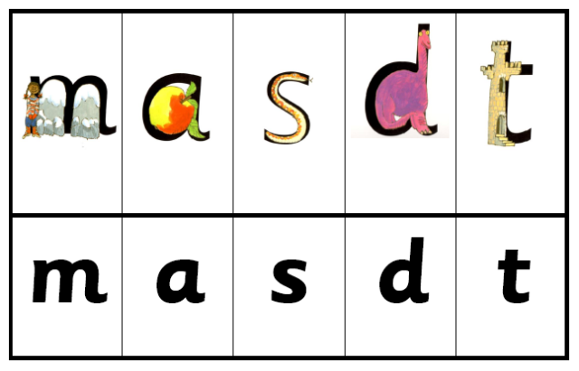  - Kites  2016-2017

We all know that reading opens the door to all learning.  A child who reads a lot will become a good reader.  A good reader will be able to read challenging material.  A child who reads challenging material is a child who will learn.  The more a child learns the more a child wants to find out.  It is therefore, vital that your child finds learning to read and write a rewarding and successful experience.  This booklet outlines how Read Write Inc works.  We hope you will not hesitate to ask for any help throughout their learning journey. We are here for your child! |  |  | Speed Sounds Set 3  Children then move on to set 3 sounds and continue to be challenged with story books and writing activities. The set 3 sounds are highlighted in pink as you can see for one spoken sound (phoneme) such as ‘ay’ – there can be a number of ways to write that sound (grapheme). For example:  Play = p-l-ay  Snail – s-n-ai-l  Cake = c-a-k-e  The sound you hear is in these words sounds the same, but is written using a different letter pattern.
 |  |  | 5

You will find it harder to avoid saying uh at the end of these sounds.  d – (tap tongue behind the teeth)  g – (make soft sound in throat)  b – (make a short, strong b with lips)  j – (push lips forward)  w – (keep lips tightly against teeth)  qu – (keep lips pursed as you say cw – unvoiced)  The short vowels should be kept short and sharp:  a: a-a-a 9open mouth wide as if to take a bite of an apple)  e: e-e-e (release mouth slightly from a position)  i: i-i-i (make a sharp sound at the back of the throat – smile)  o: o-o-o (push out lips; make the mouth into o shape)  u: u-u-u (make a sound in the throat)  Speed Sounds Set 2  Once the children know all Set 1 sounds by sight and uses them to blend to read words, we start teaching Set 2.  oo oo ar or air ir ou oy ay ee igh ow  Each sound has a rhyme to accompany it when the sound is taught. For example the word play cannot be sounded out as p-l-a-y. The word contains at ‘ay’ sound so will be sounded out as p-l-ay. An example of a set 2 sound card is ‘ow’ as in ‘blow the snow’ |  |  | About Read Write Inc  What is Read Write Inc?  Read Write Inc (RWI) is a phonics based program, developed by Ruth Miskin, which helps children learn to read whilst also developing a wide range of vocabulary and encouraging a love of stories.  Who is Read Write Inc for?  Read Write Inc program is for primary school children learning to read. It enables every child to become a confident and fluent reader at the first attempt. Every child who completes Read Write Inc learns to read fluently and confidently.  Why does it work?  - The systematic and lively program is organised by an in-school manager.  - All staff are trained by a Read Write Inc Trainer.  - The children read and write for roughly 20minutes twice a day, grouped according to their reading level.  - Children do not struggle because work is too difficult or get bored because the work is too easy.  - A few children who need extra support to maintain progress will be placed in intervention groups to ensure that they do not fall behind.
4 |  |  | 1
How RWI works in Kites  Before your son/daughter can start to read, they need to learn to:  - Say the sound that is represented by each letter or groups of letters. These are called ‘Speed Sounds’.  - How to blend the sounds together in a word to read it e.g. c-a-t cat. This is called ‘sound-blending’.  What are speed sounds?  In RWI phonics the individual sounds are called ‘speed sounds’ – because we want your son/daughter to read them effortlessly.  What are ‘speed sounds’ Set 1, Set 2 and Set 3?  Set 1: In Kites your son/daughter will learn the sounds below by sight. They will also learn how to blend them together to read words.  Speed Sounds Set 1  To begin with they will learn a sound a day. We use pure sounds so that they will be able to blend the sounds into words more easily.  Letter-sound pictures are used to help your child/children learn these sounds quickly.  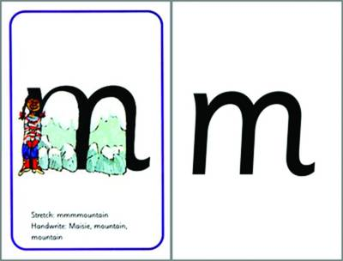  Once they have learnt the first 5 sounds we teach them to blend them. When we way words in pure sounds we call it ‘Fred Talk’. E.g p-a-n. They will then begin to read storybooks and completing writing activities to challenge them further.  . | We never use letter names at this early stage  When teaching a speed sound we either have to ‘stretch’ or ‘bounce’ it.  These first sounds should all be stretched slightly. Try to avoid saying uh after each one. E.g /mm/ not muh,  m – mmmmountian (keep lips pressed together hard)  s – ssssnake (keep teeth together and hiss – unvoiced)  n – nnnnet (keep tongue behind teeth)  f – fffflower (keep teeth on bottom lip and force air out sharply)  l – lllleg (keep pointed curled tongue behind teeth)  r – rrrrobot (say rrr as if you are growling)  v – vvvvulture (keep teeth on bottom lip and force air out gently)  z – zzzzig zzzzag (keep teeth together and make a bussing sound)  th – thhhhank you (stick out tongue and breathe out sharply)  sh – shhhh (make a shhh noise as though you are telling somebody to be quiet)  ng – thinngg on a strinnngg (curl your tongue at the back of your throat)  nk – I think I stink (make a piggy oink noise without the oi! nk nk nk)  These next sounds cannot be stretched. Make the sound as short as possible avoiding uh at the end of the sound.  t – (tick tongue behind the teeth – unvoiced)  p – (make distinctive p with lips – unvoiced)  k – (make sharp click at back of throat)  c – as above  h – (say h as you breathe sharply out – unvoiced)
2 | ch – (make a short sneezing sound)  x – (say a sharp c and add s – unvoiced) |  |  | 3

