Kites Handbook
2017-2018

People in the Early Years Foundation Stage

Head teacher Chris Hirst

Key Stage 1 Team Leader Charlotte Tugwell

EYFS teachers Charlotte Tugwell
Shrina Patel

Teaching Assistants To be confirmed

The Early Years Foundation Stage teachers have completed the same training as primary teachers and are qualified to teach primary children. The Teaching Assistants are provided with on-going training opportunities.
At certain times a Learning Support Teacher may be employed to support any children with Special Educational Needs.
Photographs of school staff and governors are displayed in reception.
Ratios of qualified adults to children: 1: 15 F1 children (Reception age, i.e. 5 years of age in the academic year)
The Unit has been assessed by the Early Years Advisor as being suitable for Early Years Foundation Stage (F1) pupils.
Please see the admissions policy for more details on attendance and admissions.

The School Day

School Hours
Morning sessions 8.45am (until further notice) -12.00pm
Afternoon sessions 1.00pm -3.15pm

The day falls into two sessions. Your child will stay for either a free school lunch in the school dining hall or a packed lunch.
Initially, we invite parents into the classroom with their children at 8.45am. It is hoped that this will help the children to settle and also allows parents to drop other children at their classrooms. This will continue until further notice. The day will then start at 8.55am, in line with the rest of the school.
The day will start with the children finding their name card and giving it to the member of staff taking the register. In the morning, children are divided into ability groups to teach Phonics and Maths. In the morning, children will also have time to talk to staff and friends, engage in free play inside and outside and take part in a planned activity. Half way through the morning we will stop and divide into small groups for snacks. During this time they will learn to be part of a group. They will be speaking and listening, turn taking, having stories or poems and having discussions.
During the play sessions there will be individual and small group teaching, and specific children will be targeted for this.
The afternoon session starts with a topic input. The children are then able to continue with free play inside and outside and a different planned activity. The session ends with us coming together for a story or song.
At the end of the day, it is essential that we know who is collecting your child. If we don't hear otherwise, we will assume it is a parent. If you know someone else is collecting your child let a member of staff know when you drop your child off in the morning. All parents/carers are asked to wait outside the gate and we will deliver your child to you, so we can ensure he or she goes to the right person. We ask you to pick your child up promptly at the end of the day, as it can be distressing if a child sees others being collected and fears that they have been forgotten.

Early Years Foundation Stage Clothing
We wear sweatshirts and t-shirts with a 'Sonning Common Kites' logo available in sky blue. Our school uniform is supplied by Marks and Spencer and is available online from https://mandsyourschooluniform.com
Although we try, we cannot guarantee that your child will keep clean, so it would be useful if a bag of spare clothes could be kept on your child's peg, as there will inevitably be occasions for a change. We aim to make maximum use of our outdoor space so children will need to come equipped for all weathers!
Children will need shoes, plimsolls or trainers for P.E. and wellies. Please help your child to be independent in changing their own shoes by providing ones that easily fasten.
In summer, your child will need a named sunhat.
Shorts and t-shirt are required for PE activities which should be labelled in a suitable bag. Plimsolls or trainers will be needed from February.
It is essential to name all clothing or it will be impossible to track down if it goes missing (Biro is not reliable as it washes out!)

Water and snacks
Children are provided with fresh fruit or vegetables for break times. You are encouraged to provide them with a water bottle that will be available for them to use whenever they are thirsty.

Home/School Communication
We try very hard to keep parents regularly informed about what’s going on in school: there are weekly whole-school newsletters, PTA newsletter. A service called Parentmail is used by school to email newsletters and general information to our parents. As well as sending emails, it has the additional benefit of being able to send text messages to your mobile phones if we need to get an important or urgent message to you.

Every child will need a book bag for their home reading books, personal belongings and sometimes also for homework or communication. They are available from Marks & Spencer. If you want to pass a message to your child’s teacher you could put a note in your child’s book bag, leave a message with the school office or speak to the teacher or a member of staff. It is important to check your child’s book bag daily as from time to time notes will need to be acted upon quickly.

Website
www.sonningcommonprimary.co.uk
The website is wonderful and provides a lot of general information including term dates, an events calendar, the school prospectus, school newsletters, P.T.A. information and photos and descriptions of recent or upcoming school activities. Kites have their own page on the website which keeps parents updated with information about what we have been learning.

Opportunities to discuss your child's progress
In the autumn term and spring term, parent consultations take place to update you on your child’s progress. Towards the end of the summer term you will receive your child's end of year report. However, children’s lives and learning seldom conform to a timetable so please feel free to come in and make an appointment to speak with your child's teacher at any time if there is an issue you wish to discuss.

Opportunities to follow your child’s progress
We use an internet based programme called ‘Learning Book’ which we update regularly with pictures and comments about how your child is progressing. We will give you the login details to enable you to follow and comment on your child’s progress.

Health
Please keep your child at home if he or she has been ill during the night and if they have suffered from diarrhoea or vomiting they should remain off school for 48 hours. If you child has head lice, threadworms and conjunctivitis they are all very infectious and must be treated and have a clear 24 hours before returning to school. If your child is absent for any reason, please let us know by telephone. If your child is ill during the day, we will contact you immediately, so please keep us informed of changes of address and daytime contact numbers. If you are going to be somewhere different for the day, please let us know a contact number as you drop your child off. We are advised not to administer medicines to children at school, except in special circumstances such as asthma. Please talk to the Head teacher if there are other circumstances. If your child has any kind of serious food allergy, a photograph of your child together with the allergy list and consequences, should be provided to your child's teacher for display on the staff notice board.

Holidays
While we expect your child to attend school during term times, we acknowledge that on rare occasions it may be necessary for them to be absent. In this instance, please complete a permission form, available from the School Office.
Sonning Common Primary School Accident/injury policy in the Foundation Stage:;

Accidents/injuries are noted in the accident book.
An accident/injury that has involved another child is discussed with the children in question immediately.
If an injury has been caused by another child deliberately, it is: discussed with the child noted in the accident book (for evidence if needed at parents' consultations or if a pattern of behaviour can be established)
Discussed with the offending child's parent and the victim's parents.

Head injuries will be reported to the child’s parents as soon as possible. The accident book is reviewed termly so that any patterns / common causes of accidents can be noted and dealt with where possible.

Parent Teacher Association
We have a thriving and energetic parents association that organizes numerous social events and raises extra funds for the school. They produce a termly newsletter to keep you informed of forthcoming activities and would welcome your support and involvement.
On the first morning in September, after leaving your child, you are invited to join other parents in the hall for Tea and Tissues hosted by the PTA.

Bookshop
The school has a bookshop that is open on Wednesday mornings. It has a selection of children's books as well as cheaper items such as pencils, rubbers and notepads. Children can bring money and buy stamps to save up for a book they like. We take all the children for an initial visit to the bookshop so that they can see what is there and then subsequently we visit once a term.

Forest Camp
The children in Kites visit the Forest Camp (in the school grounds) once a week with a Forest School leader and another member of staff.
Forest Camp offers the children opportunities to make choices, initiate learning and take risks. It offers them different ways to learn and experience a full curriculum in a woodland environment. It also encourages positive attitudes and behaviour.

The children develop:
personal confidence and self-esteem
communication and social skills
a wider range of physical skills than are usually developed indoors
a deeper understanding about their own natural and made environments
increased knowledge about wider environmental issues
their innate motivation and positive attitudes to learning and citizenship.

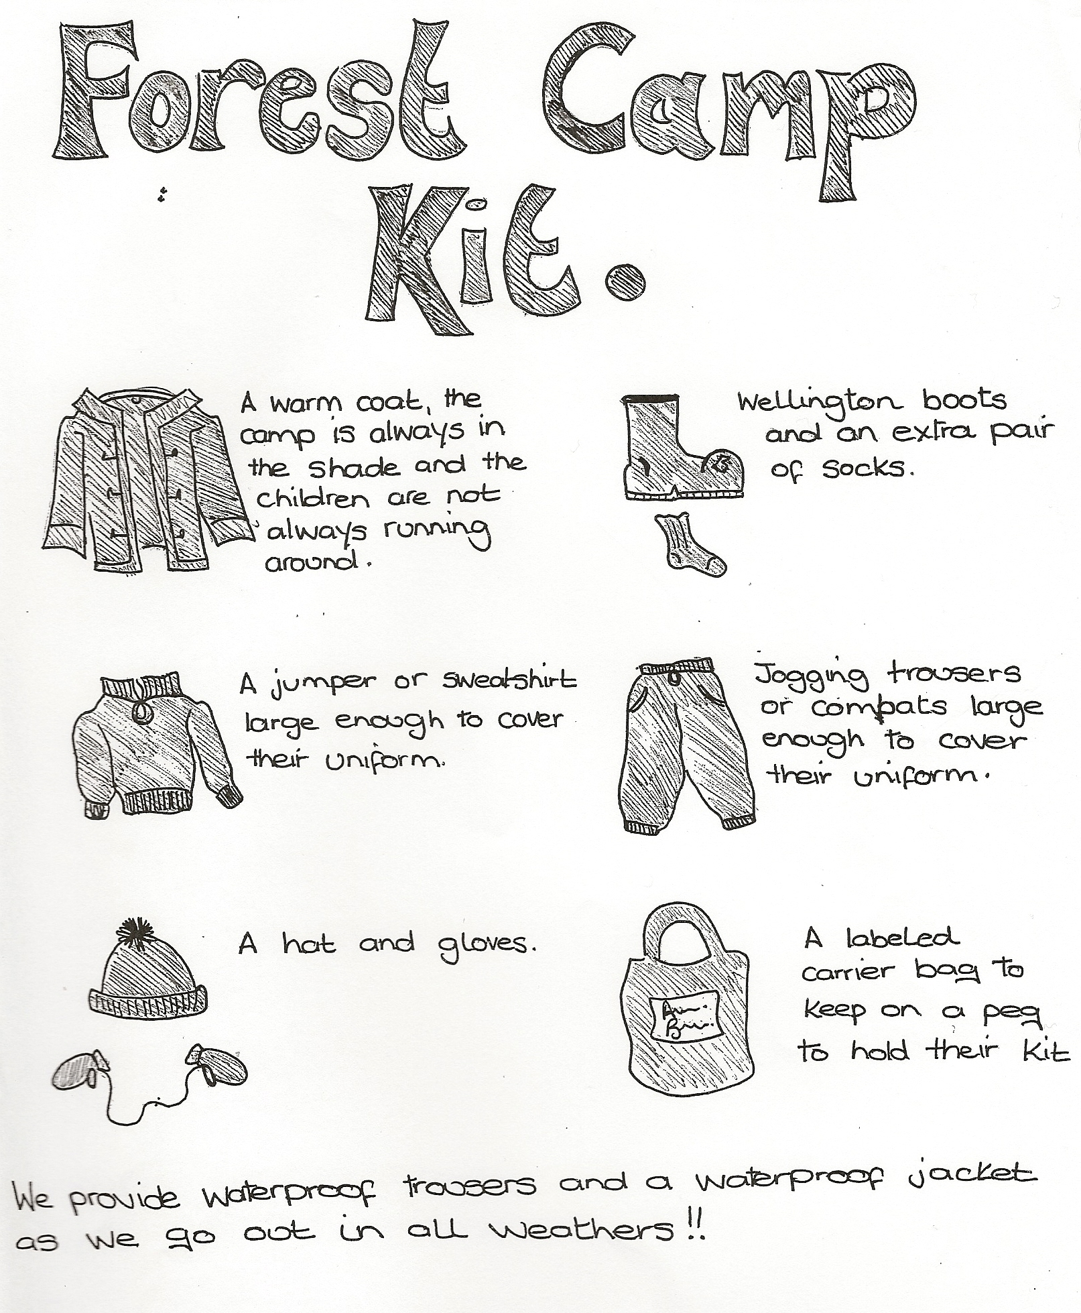

Encouraging Good Behaviour in the Foundation Stage
We would like children to be able to:
· Speak politely to those around them e.g. referring to people by name and saying please and thank you.
· Tell the truth.
· Sit and listen attentively, without calling out, for short periods.
· Follow simple instructions, do as requested by an adult.
· Find classroom equipment and tidy it away when they have finished.
· Resolve disputes by talking.
· Work with a partner in a constructive manner - sharing and listening to each other's ideas.
· Play safely - have some thought for the consequences of their actions both for themselves and others.
· Take care of equipment.
We would encourage this by:
· Adults within the unit modelling the kinds of behaviour we want to see in the children.
· Praising and rewarding children who behave in appropriate ways and explaining what they
; Parental Involvement
Working in partnership with parents is a key element to a child's successful learning. Help and support from parents/carers is welcome, both at school and at home. Working together with parents is the best way to support children in their opportunities for learning at the Foundation Stage and to complement the learning already going on at home. If you would like to help please sign up on the timetable. Helping out in the classroom is a great way to find out about what and how your child is learning. If you have an occupation or skills that you would like to share with us, please let us know.

How you can support your child at home?
· By having conversations with each other
· By listening to your child and encouraging your child to listen to you
· By sharing activities and talking together about them
· By encouraging your child's interests
· By taking an interest in the work your child brings home
· By borrowing and sharing books
· By playing with your child
· By letting them help you with every day activities at home e.g. Cooking, D.I.Y., drawing, writing, shopping, etc.
· By sharing in all that your child does at Foundation Stage and by participating in Foundation Stage life, e.g. Helping with outings, collecting things, contributing to displays.

All the parents/carers who participate in these activities are helping the child to make connections with the world around them, which is the most important life skill.

