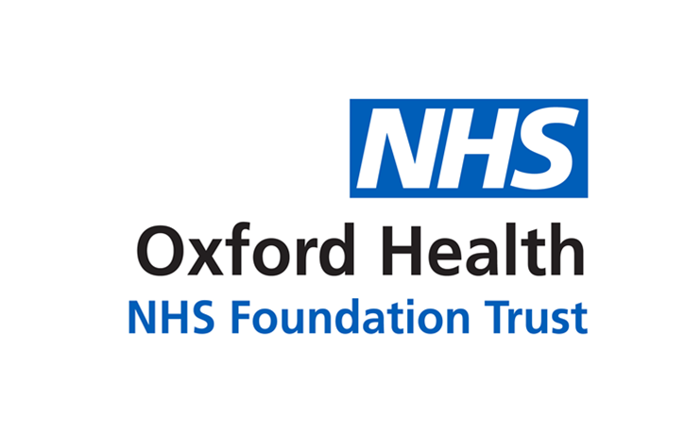
Primary School Health Nurse Team Newsletter
Term 1 September 2017

Starting School
We would like to take this opportunity to introduce the school health nursing service in Oxfordshire. The service is commissioned by Public Health at Oxfordshire County Council and is provided by Oxford Health NHS Foundation Trust. The school health nurse teams are based in community hospitals or health centres. The teams are led by a school health nurse supported by a community staff nurse and a school health nurse assistant. Contact details for your school health nurse are available from your child’s school, or on our website:
http://www.oxfordhealth.nhs.uk/children-and-young-people/oxon/school-health-nursing/

School Entry Health Review and Medical conditions
It is important that school staff are aware of any medical conditions your child may have when starting school, this includes conditions that may be under control and managed purely at home. The Primary School Health Nurse team can offer your child a health review, to discuss your child’s specific health needs during the school day. To arrange a review please contact the Primary School Health Team nearest to your child’s school. Further information about our service will be sent to all reception pupils via school during September.



This newsletter aims to provide families and young people with some useful tips for keeping healthy. Childhood is an important time to instill healthy habits and learn crucial life skills. Establishing these habits early on will help to improve your child's quality of life in the future and enable them to reach their full potential educationally.

https://www.facebook.com/oxschoolnurses/
Oxford School Health Nurses are now on Face book. The page has been running since the beginning of the summer holidays and to date has been viewed by nearly a thousand people! The social media team who manage the page have created a lively and dynamic information set that can inform parents and young people what their school nurse team can offer them. We use videos, links to other sites and also create our own media.


As well as nationwide public health messages we give local information on what’s on and what services they can access. The team can see at a ‘click’ who has seen the page, whether they ‘like it’ and monitor any responses so they can be responded to in a timely manner. This page is a really useful way to inform parents of latest, local events and we will be signposting parents to use it to keep up to date on what is going on for health for their child.


The World Health Organisation state that the two public health interventions that have had the greatest impact on the world’s health are clean water and immunisations.
Routine immunisations are offered free of charge by the NHS and are an important way of protecting your child against life threatening diseases.
By the time your child starts Primary School they should have completed their Primary course of immunisations and received their pre school boosters at your GP practice.
If you're not sure whether your child has had all their routine vaccinations, refer to your child’s ‘red book’ or ask your GP or practice nurse. The full immunisation schedule for children under 5 can be accessed at: https://www.gov.uk/government/publications/routine-childhood-immunisation-schedule
Immunisations

The school based seasonal flu vaccination will be offered at school for children in Reception and year 1, 2, 3 & 4 between October and December. The vaccination is painless and free. It is given by a quick and simple spray up the nose.
If your child is eligible you will receive a consent form from school, please complete this and return it to school as soon as possible, completing all sections. It is essential that you supply your child’s NHS number so their medical records can be updated promptly. You can find your child’s NHS number in their Parent held child health record, ‘Red book’ supplied when they were a baby, on their NHS Medical Card or from your GP surgery.
If your child becomes wheezy, has their asthma medication increased or subsequently receives vaccination outside of school after you return the consent form; please contact your local School Nurse team on the details below.
If your child is absent or unwell on the day of the school visit, there will be a catch up clinic arranged by the school nurse team on an alternative date.
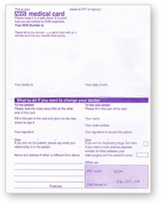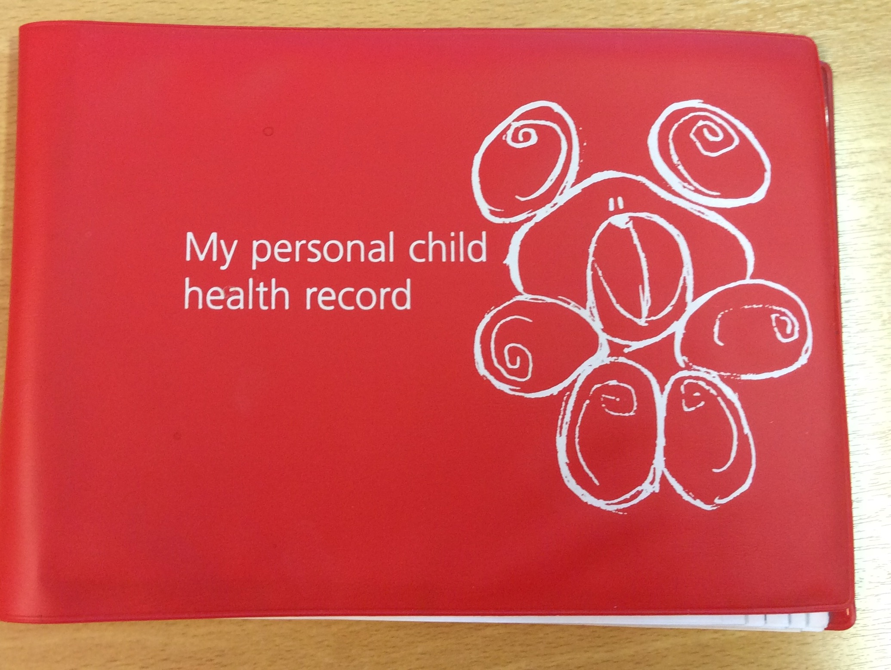

New flu email address, for queries
flu.schoolnurses@oxfordhealth.nhs.uk

Further information is available at:
www.nhs.uk/child-flu


To contact the SHN Team in your locality Tele: 01993 867149 Email:Carterton.shns@nhs.net
The school health nurse for your school is Helen Newitt



