To inspire with the joy of life-long learning.

Vibrant learning in a caring environment.

Sonning Common Primary School
Grove Road, Sonning Common, RG4 9RJ.
Tel: 0118 9722105.
www.sonning-common.oxon.sch.uk

Headteacher: Mr C. Hirst Chair of Governors: Mrs J. Million

CONTENTS

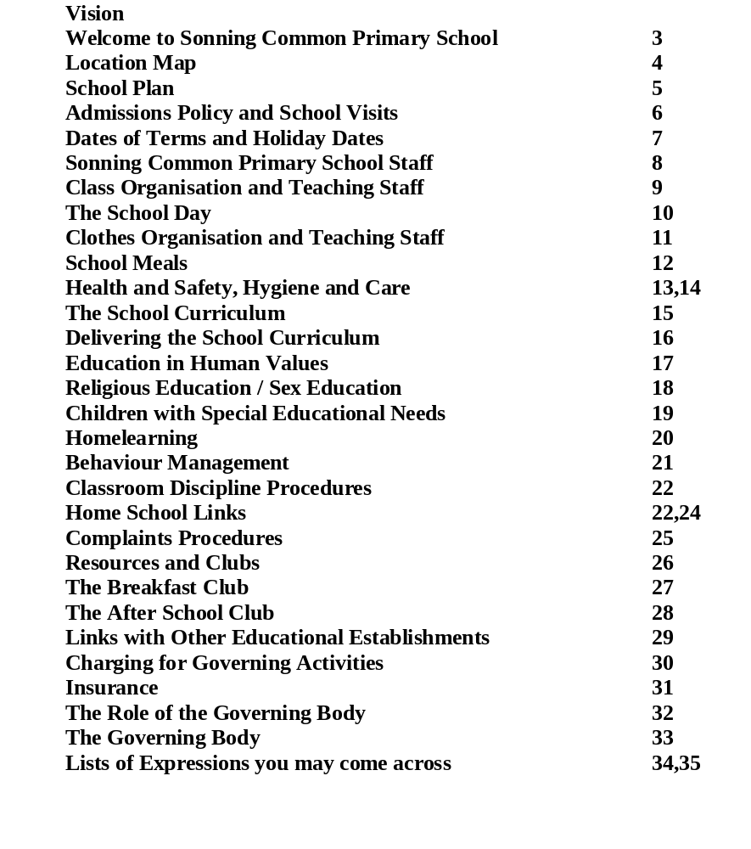

WELCOME TO SONNING COMMON PRIMARY SCHOOL

Welcome to the community of Sonning Common Primary School. Our school is a values-led community school, which means the life of the school is centred on making good relationships, on teamwork and caring for others. The staff here is dedicated to providing an education for the whole person, giving them an exciting and interesting start to life-long learning.

All aspects of children’s learning are important and there are opportunities to enjoy sport, drama, dance, music, the environment, a foreign language, as well as the all important skills which enable children to be literate, numerate and scientific.

We encourage learning in many different ways through the use of excellent facilities at the school such as the library, the swimming pool, the computer room, large classrooms and extensive grounds. The staff is a wonderful blend of wisdom, youth and experience. An energetic governing body and a very active Parent Association support them. All of these adults provide a calm and nurturing environment for the children.

We are most fortunate in having Bishopswood Special School on the same site. By working and playing with Severe learning Disabilities (S.L.D.) children our mainstream children gain valuable social skills that will remain with them for the rest of their lives.

The school welcomes parent help in the classroom and encourages parents to express their views through questionnaires and regular meetings. We value highly the contact between home and school, knowing the process of educating a child is a partnership. Parents and teachers working together will give children the opportunity to develop talents and encourage tolerance, independence, good behaviour and positive attitude to learning.

Mr Chris Hirst Mrs Jackie Million
(Head teacher) (Chair of Governors)

LOCATION MAP

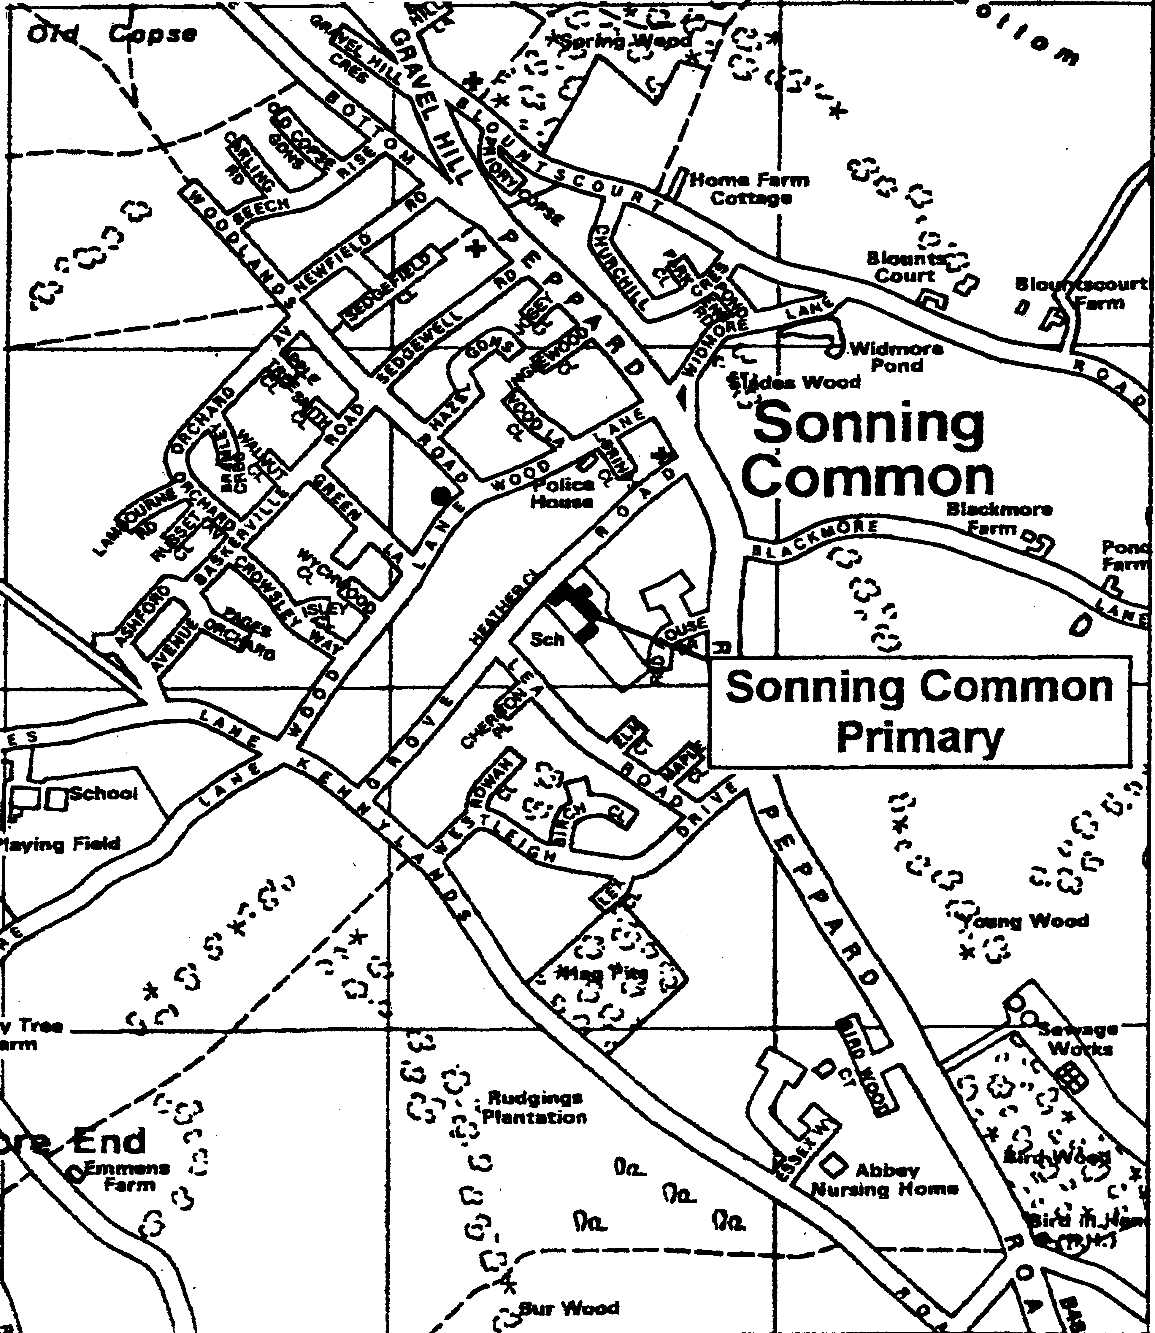

CATCHMENT AREA FOR
SONNING COMMON PRIMARY SCHOOL

SONNING COMMON SCHOOL PLAN

ADMISSIONS POLICY

Sonning Common School serves the Sonning Common Village catchment area. Children from outside Sonning Common do come to the school but only after proper consultation with the headteacher of the area concerned and if space in the school permits.

Children are admitted part-time at the commencement of the year during which they have their fifth birthday. The maximum admission number allowed is 50 pupils in each age group, although this may be exceeded upon occasion.

Applications to the school are given priority as listed below:-

I. Children resident within the catchment area

2. Brothers and sisters of children already in attendance at the school

3. Children from outside the catchment area

If there is a problem about an application it will be assessed by a committee consisting of the Headteacher and two other members of the governing body. Further appeals can be made to the Chief Education Officer if the matter is not resolved to the satisfaction of parents.

SCHOOL VISITS

There is one formal Open Morning a year to which prospective parents are invited.
This provides a guided tour of the school grounds and an opportunity to meet the head teacher, parent governors and pupils.
Alternatively, parents can make individual appointments to visit the school.
In both cases the school secretary should be contacted on 0118 972 2105.

SCHOOL TERM & HOLIDAY DATES 2008 – 2009

Term 1
Monday 1st September INSET
Tuesday 2nd September INSET

Wednesday 3rd September – Friday 24th October 2008

October Holiday – Monday 27th October – Friday 31st October 2008

Term 2
Monday 3rd November – Friday 19th December 2008 (school finishes at 1.15pm)

Christmas Holiday – Monday 22nd December – Friday 2nd January 2009

Term 3
Monday 5th January 2009 INSET

Tuesday 6th January – Thursday 12th February 2009

Parent Consultation Day – Friday 13th February

February Holiday – Monday 16th February – Friday 20th February 2009

Term 4
Monday 23rd February – Friday 3rd April 2009 (school finishes at 1.15pm)

Easter Holiday – Monday 6th April - Friday 17th April 2009

Term 5
Monday 20th April – Friday 22nd May 2009

May Day Holiday – Monday 4th May

Late Spring Holiday Monday 25th May – Friday 29th May 2009

Term 6
Monday 1st June – Friday 17th July 2009 (school finishes at 1.15pm)

Monday 20th July INSET

SONNING COMMON PRIMARY SCHOOL

Head teacher: Mr C Hirst

Deputy Head teacher: Mrs M White (Special Needs)

Class teachers:
Miss J Price (Team Leader KS2, Geography KS2, Mrs J Pound (KS1 Team Leader,
Assessment KS2) KS1Assessment KS1)
Miss K Gordon (Maths) Miss R Bartlett (Environmnet)
Miss C Winton (PE & Games) Mrs G Rice
Mrs L Hems (Science, Design Technology) Mrs G Thurlow (Religious Studies)
Mrs P Humm (Music) Mrs M Mills (Art & Craft)
Mr M Lovegrove (ICT) Mrs M White (Special Needs)
Miss R Offer (English) Mrs L Hanks (PHSCE)
Mrs K Ashton Mrs F Bodenham (Geography)
Mrs V Harris (History) Mrs J Quinton (French)

Secretary: Mrs C Matthews
Bursar: Mrs K Estcourt

Support Staff: School Nurse – Sandra Stickland
Speech therapist – Lesley Morgan
Physiotherapist – Lynn Hohnson

Teaching Assistants:
Mrs S Green Mrs W Stowell Mrs S Evans Mrs P Doughty
Mrs G John Mrs Y Room Mrs L Myhill Mrs P Byrne
Mrs G Merricks Mrs E Steele Mrs H Robins Mrs S Hinks
Mrs S Stevenson Mrs C Conway Mrs C Meredith Mrs D Challis
Mrs S Dryden Mrs C Byrne Ms S Craft Ms M Genneper
Mrs G McGowan

Caretaker: Mr P Butler Cleaner: Mrs S Butler

Catering Supervisor: Mrs J Wise

Kitchen Staff: Mrs B Sadler Mrs P Harmsworth Mrs S Butler

Lunchtime Supervisors:
Mrs B Pound Mrs S Green Mrs C Meredith Mrs Y Room
Mrs G John Mrs C Byrne Miss D Patterson Mrs K Maulini

Road Crossing Patrol: Miss D Patterson
Class Organisation and Teaching Staff for 2007/2008

Sonning Common Kites
Miss Bartlett / Mrs Humm/ Mrs Rice/
Infant
Year 1
Mrs Pound / Mrs Mills/ Mrs Thurlow
Year 2
Mrs Hanks / Mrs Bodenham
Mrs White / Mrs Bodenham
Junior
Year 3
Mrs Harris / Mrs Ashton
Year 3/4
Miss Offer
Year 4
Mr Lovegrove
Year 4/5
Mrs Hems
Year 5
Miss Winton
Year 6
Miss Price
Miss Gordon

Mrs White - SEN Coordinator throughout the school

Number of pupils on roll

September 2008 - 362

THE SCHOOL DAY

PARENTAL OBLIGATIONS:

Parents are encouraged to walk to school with their children. They should not be at school before 8.45am after which time they are officially under school supervision. All children are expected to arrive at school before 8.55am. There is a breakfast club for children whose parents wish to drop them earlier than 8.45a.m.

It is the legal responsibility of parents to ensure that their children attend school punctually and regularly.

School hours: Morning: 1st session 8.55 to 10.50am
Break 10.50 to 11.10am
2nd session 11.10 to 12.15pm

Afternoon: 1.15 - 3.15pm
Infant break 2.30 - 2.45pm

21 hr 45 min for 5-7 year-olds
23 hr 15 min for 8-11 year-olds

(These times do not include time spent in collective worship and registration)

Parents are requested to send a note in the event of their children being absent. It is helpful to the school if parents telephone to inform us on the first day of absence.

The school must be informed if parents wish to collect their children during school hours or if the child is to be collected by a different adult.

Children are not allowed to leave school during school hours without the agreement of both the school and the parent.

In an emergency we will need a telephone number so parents can be contacted.

Parents are encouraged to sign the Home-School Agreement but there is no statutory obligation on them to do so.
CLOTHES AND EQUIPMENT FOR SCHOOL
School uniform is compulsory, as indicated in the list of clothing in the appropriate
colours below.

Girls:
Navy blue skirt or pinafore dress (knee length) with white or navy blue socks or navy blue tights.
Full length navy blue trousers.
Pale blue polo shirt or blouse (this helps us make sure all children change for P.E.)
Grey shorts with grey socks.
Summer dress: blue/white gingham with white socks.
*School sweatshirt or navy blue jumper / cardigan with school badge.
Sensible black or navy shoes (heels no more than half an inch).
Boots must NOT be worn.
At all times:
Long hair must be tied back. Hair accessories should be discreet and in school colours.
No jewellery or make-up is allowed. (For pierced ears discreet studs may be worn).

Boys:
Trousers or shorts in grey.
Pale blue polo shirt or shirt.
*School sweatshirt or jumper with school badge. Navy blue only.
Grey socks.
Sensible black shoes.

P.E.
Navy shorts, white T-shirt, socks and trainers.
All in a separate named bag.

Swimming
Swimsuit, towel, swimming hat.
All in a separate named bag.

Sports kit – Year 3 upwards
Long navy socks, trainers, football boots, shin pads, navy tracksuit .
All in a separate named bag.

All clothing must be clearly labelled.
*School sweatshirts, badges, swimming hats, P.E. bags and book bags are all supplied by the Parents Association. Order forms are available from Reception.

Kites wear an optional uniform of light blue sweatshirts and T-shirts.

SCHOOL MEALS

The LEA provides midday meals on the premises at a standard charge set by the Authority. Payment should be made preferably on a Monday morning for the whole week. The school is under no obligation to give children meals without payment and parents should write a note if for any good reason payment cannot be made. Some children qualify for free meals and forms can be obtained from the school secretary. The present charge is £1.95 per day. No distinction is ever made at a meal between those children who pay and those who do not. Free meals are authorised for six months at a time. If a parent wishes to continue to claim it is important to keep the Income Support form as meals can only be received when the form is produced as proof of continuing entitlement.
The school offers facilities for children to eat a school lunch at midday or to bring a packed lunch. The meal is prepared on the premises by the cook supervisor working with an experienced team of kitchen staff. All meals are eaten in the hall supervised by lunchtime assistants and a teacher on duty.
Whenever the weather is fine the children play outside during the remainder of the lunch hour. If the weather is poor they stay in their classrooms. Children are usually provided with activities or involved in games or stories. Midday assistants provide supervision. Children are not permitted to leave the premises without written parental permission, and the agreement of the school.
Children in Key Stage 1 are provided with a free piece of fruit each day at break time. Key Stage 2 children are allowed to bring in fruit for mid morning break or alternatively they may purchase fruit daily from the Fruit Tuck Shop.

COUNTY CATERING

County Catering, which is the body behind your child's school meal, has on offer a menu that is balanced, nutritional and varied. This includes a daily choice of menu, vegetarian dishes included. In addition it is possible to cater for children with special diets, when advised by parents.

With such a wide range on our menu we would like to see more children use the service. We realise that cost can sometimes be a problem; if information is needed on this it can be obtained from the office. The Menus are posted on the school notice boards in the infant and junior playgrounds.

If there are any problems with the catering I can be contacted through the school.

The Catering staff look forward to serving your children.

Joyce Wise - Catering Supervisor
HEALTH AND SAFETY, HYGIENE AND CARE

As with children's academic progress, their physical well being requires the close co-operation of parents and staff. In addition, the school nurse is available to help with any problems that may arise. The school is part of the West Berkshire Area Health Authority. During the first year at school children are asked to attend a medical with the school nurse or doctor. Parents are, of course, always invited to attend. The school nurse carries out eyesight and hearing checks.

Parents are asked to inform the school of any serious illness or unusual contagious diseases such as stomach bugs, head lice, conjunctivitis or impetigo. Parents must provide the school with information of any allergies. A photograph of the child is also required.

In case of injury that happens on the school site, staff are only allowed to carry out the most basic first aid. Creams and medicines must not be applied. The school will refer children thought to have serious injury to casualty and the parents will be informed as soon as possible. The school cannot undertake to give children tablets or medicine prescribed by a doctor unless it is for a chronic condition (all staff undertake Epipen training). Children should not be sent to school in possession of medicine or any kind of drug. In the case of asthma, parents should supply the class teacher with all the necessary equipment that will be kept in the classroom and used when the child requires it. Older pupils will look after their own inhalers.
Children who have been ill may at the written request of a parent, stay indoors at break or lunch with the understanding that the child may not be supervised. Otherwise, a member of staff will always supervise children who do stay indoors

Child protection

Under the requirements of the Children's Act 1989, we have a responsibility to work with the Area Child Protection Team. The school is not an investigation or intervention agency for child protection but it has an important role to play at the recognition and referral stages. The headteacher and deputy are the designated teachers for any child protection issue.
Hygiene

In the interests of cleanliness, pupils must always wash their hands before lunch, after using the toilet and after doing litter duty.
Children must also have T-shirts, shorts, socks or track suits to change into for games throughout the year. During wet, muddy weather and hot summers these changes of clothes are very important. A swimming hat is also required for swimming. Children's PE clothing should be kept in a bag and taken home for washing at the end of each week. The kit should then be ready for use at the beginning of the following week.
The school keeps up-to-date literature on all medical matters relating to children in schools. There is a policy for children who suffer from asthma.

Fire Drill

Fire drills are carried out once a term so that children and staff know exactly how to proceed in an emergency.

Safeguard

The school has a security system whereby all visitors on site have to sign in and know the emergency procedures. Any adult on site during the day without a visitor’s badge will be immediately challenged.

Travel

The school will always endeavour to hire coaches and buses with three-point seat belts. Failing these, coaches with lap belts will be used. Under these circumstances the school has taken all the necessary steps to ensure that children are safe on trips whilst travelling on coaches. Parents who are unwilling to allow their children to travel on coaches without three-point seat belts should communicate this to the school and those children will be supervised on the school premises.
Cars may be used to help with school trips when coaches are not available, only if all the children have appropriate booster seats and proper seat belts and the driver and the vehicle fulfil all current legal requirements.

Road Safety Education
Parents have the primary responsibility for road safety training for their children, but the school does carry out related activities. There is a cycle training programme for the older children, and they are allowed to cycle to school.
Pupils are encouraged to walk to and from school, rather than be driven by car, if at all possible.

THE SCHOOL CURRICULUM

Through its curriculum policy the school aims to develop effective and efficient learning and progression for all its pupils at Key Stage 1 (Kites, Years 1 and 2) and Key Stage 2 (Years 3 to 6). It does this with the participation of, and in consultation with, governors and parents. Emphasis is placed on the involvement of the local community, the world of work and supporting agencies
and organisations, which may have valuable contributions to make to the process. A complete policy statement on the School Curriculum is available on request from the School Secretary.

The school regards English, mathematics, science and information & communication technology (ICT) to be the core curriculum subjects at primary level. History, geography, food and design technology, music, art & craft, physical education and social moral spiritual & cultural education are all important areas of the curriculum often bound together in project work. Religious education remains statutory.
Additional subjects such as values education, environmental education, sex education, philosophy and health and safety are all important aspects of the school's curriculum. Children in Years 1 to 6 have French lessons.

Delivering the National Curriculum

The Governors and staff at Sonning Common Primary are responsible for ensuring that the National Curriculum is delivered effectively to all the children in the school.
The Governors fully endorse the attainment targets and programmes of study in all subjects.

The framework and purposes of the National Curriculum are to:
- provide opportunities for all pupils to learn and to achieve
- promote the spiritual, moral, social and cultural development of pupils and prepare all pupils for the opportunities, responsibilities and experiences of life.

The National Curriculum also states in relation to each subject:
- the knowledge, skills and understanding which pupils are expected to have by the end of each key stage
- the programmes of study required to be taught during each key stage
- the arrangements for assessing pupils at or near the end of each key stage
The results of these assessments and tests will be made available to parents.

Children have a pupil profile that monitors their progress in school. There are opportunities for parent/teacher consultations during the year and we provide a written record at the end of each year in accordance with the requirements of the 1986 Education Reform Act.
SOCIAL MORAL SPIRITUAL and CULTURAL EDUCATION, EDUCATION in HUMAN VALUES

This vitally important aspect of the school curriculum is dealt with in many ways through religious education, sex education, assemblies and class discussion time.

At the beginning of every school year the children review the code of behaviour which they have written and developed over past years. Class time is given to human values education, 'circle' discussion time and debates. Staff choose the format they work with most comfortably.

Children learn to –
focus and concentrate
listen to others without interrupting
consider arguments carefully before responding
respond in a civil manner
respect other points of view
laugh with but not at
back up their discussion with good evidence or examples

School’s Council

This is an introduction, for all of the children, to the democratic process.
Every KS2 class sends elected representatives to a weekly council meeting. The
council has a budget and it makes decisions about improving facilities for all pupils.

RELIGIOUS EDUCATION AND COLLECTIVE WORSHIP

In accordance with the 1988 Education Reform Act the governors at Sonning Common Primary recognise the special status of Religious Education as part of the basic but not national curriculum. It has equal standing in relation to the core and other foundation subjects (but is not subject to nationally prescribed attainment targets, programmes of study and assessment arrangements).

The school policy is to arrange a number of main themes during the year including major religious events such as Christmas and Easter which are mainly Christian in content. At the same time, however, the staff take into account 'the teaching and practices of the other principal religions represented in Great Britain'.

Themes for collective worship are planned for each school term. These themes will be derived from the values education programme and world religions and will complement work done in the classroom.

The school gladly welcomes children from all denominations and religions.
Arrangements can be made for separate acts of worship, as necessary. Parents may request that their child be excluded from acts of collective worship and religious education. Children excluded will be accommodated in other classrooms.

SEX EDUCATION POLICY

The governors in consultation with the Headteacher, staff of the school and the school nurse make the following recommendations for sex education within the school.
* that generally only the oldest children in the school be involved in any formal sex education
* that sex education is best contained within the science curriculum
* any framework of sex education should be contained within a general policy emphasising the importance of family life and stable personal relationship
* that any parent should have the right to withdraw their child from receiving sex education at school
* that parents have the right before their children are involved, to see any teaching materials which will be used with their children

CHILDREN WITH SPECIAL EDUCATIONAL NEEDS (SEN)

The Governors recognise that Special Educational Needs is a term applicable to gifted and talented children as well as those who have physical, emotional or learning difficulties. Sonning Common Primary, in co-operation with the parents and Local Education Authority, always seeks to ensure that the special needs of children are met.
Teacher observations and assessments identify those children of above average ability. Teachers consider their needs when the term's work is planned and extension topics are always included. Clubs and music lessons extend children talented in sport and creative arts. Resources and advice are available from the Special Needs Co-ordinator (Senco).
Oxfordshire's policy, in regard to children with learning and physical difficulties, is one of inclusion - children with special needs being cared for by their catchment area school.
The school provides teaching assistants (TAs) to work alongside children when necessary. The school is also able to call on the professional advice of an educational psychologist, speech therapist, physiotherapist, outreach teacher, behaviour support and social services.
Children with learning difficulties are identified by parent and teacher observation and assessment and referred to the Special Needs Co-ordinator. The school follows the DfES Code of Practice (described in the Special Needs Policy).
The progress of children with SEN is carefully monitored and Individual Education Plans (IEP) prepared as necessary. Parents are invited to attend reviews of their child’s progress towards meeting targets.
A special needs register is kept and updated termly. Success is measured through the progress made by individual children towards achieving the targets set out in their IEPs. Each year some children will make such significant progress that they are removed from the register.

HOME LEARNING

Infant Department (Key Stage 1)

Children are given the opportunity to take home a book each day to share with an adult. They must return it before taking another one. They may occasionally be asked informally to “find out about something at home” and given activities to take home which support their learning.

Lower Junior Department (Key Stage 2)

Children are given the opportunity to take a book to read at home. There are regular tables tests and children will be asked to prepare "talks" on a subject of their own choice and prepare book reviews.

A list of activities to be done as home learning will be given for some projects from which children can select the areas that interest them. They will, however, be given an item from this list as home learning each week. It is hoped that parents will support children in their work whilst encouraging personal organisation and responsibility.

Upper Junior Department (KS2)

Children will have regular tables and spelling tests. In addition they will be asked to prepare some pieces of work for presentation to the class, prepare "talks" and debates for the class and they should read at home regularly.

It is expected that upper juniors will pursue a topic for project work that may take a variety of forms and that they will carry out some independent study and research, with support from parents. It is hoped that this will provide opportunities for personal organisation, developing research skills, making choices and allow them to take independent responsibility for their own work.

BEHAVIOUR MANAGEMENT

After consultation between the staff and governors it was decided that a whole school policy to deal with disruptive behaviour and reward good behaviour in a consistent manner was required. The policy is fully explained to all the children so that they understand the consequences of poor behaviour.

Classroom management becomes more effective once children understand a good code of behaviour. Teachers can then proceed to do the job they are paid for - to educate children.

Parents have a large part to play in this strategy. Home backgrounds affect children's behaviour. The most effective schools appear to be those that have created a positive atmosphere, based on a sense of community and shared values.

Sonning Common has always encouraged this form of liaison with parents and will continue to do so.

Childrens' responsibilities

We have decided not to have a list of school rules, but rather, a list of
responsibilities which has been developed with the children and to which they will all try to adhere. This will be reviewed at the beginning of each school year and is frequently referred to during the school year. It is published and displayed in every classroom in the school. Alongside this will be a charter of pupils’ rights.

CLASSROOM DISCIPLINE PROCEDURES

If a child is disruptive in class he or she will be told what it is that is disruptive and be
asked to desist.
If the poor behaviour continues the child will be reminded of his/her responsibility to
ensure that other children can have continuous learning. He or she will be asked to behave correctly and it will be made clear that if he/she does not they will be required to go to another classroom for the rest of the lesson.
If the child is asked to go to another classroom a letter will be sent home to his/her parents explaining what has happened. Should this happen more than once in 10 days the parents will be asked to come into school to discuss the matter with the class teacher and headteacher.
Should a child refuse to leave the classroom when requested to do so, a senior member of staff will be asked to attend. This may result in a fixed term exclusion if the child continues to refuse to do as asked.

Isolation
Children who are aggressive or abusive or engage in other types of anti-social behaviour will not enjoy their normal break times and will stay in on their own and be given appropriate things to do by their class teacher

Rewards
Children can be rewarded for good work and behaviour by their class teachers in many ways, including team points and certificates. Excellence is rewarded by a specially embossed pen presented to the child by the headteacher in assembly.

HOME SCHOOL LINKS

Governors Annual Report to Parents

The Governors provide a written report informing parents about the running and organisation of the school and, at the same time, giving parents an opportunity to air their views and concerns on school issues affecting the education of their children.

Parent Forum Evenings

These are termly meetings chaired by a parent and attended by the headteacher, deputy headteacher and home-school links co-ordinator and any parents who wish to attend. The agenda is set by the parents and is an opportunity to raise any areas of concern or topics of interest.

OPPORTUNITIES FOR PARENT/TEACHER COMMUNICATION

Curriculum Sharing Meetings

These meetings take place in September during a school evening. They happen at the beginning of every year in order that staff can explain the programme of study for the year. Parents are encouraged to come so that they gain a clear picture of their children's education. They also have an opportunity to question staff about issues which require a fuller explanation, so they can give their child greater academic support. Parents may also take the opportunity to set a date for a consultation with their child's new class teacher during this meeting.

Parent/teacher Consultations
Meetings between parents and staff to discuss pupil profiles are organised as appropriate depending on the availability of parents and staff. These meetings are arranged in February, halfway through the academic year. Written reports are sent home in June at the end of the year and parents are given another opportunity to respond if they so wish. Parents are welcome to meet with class teachers after school, by appointment at any time during a school year. Parents of children with special needs will be invited to attend a meeting to review progress each term.
Parents in School

The school welcomes parents who wish to work with children in the classrooms and parental support is encouraged not only with work in the school but also activities that may be brought home. The staff welcomes parents who have specific skills in art and craft, cookery, computers and in woodwork and in any other areas. During the year the school organises a course for parents who wish to work in classrooms. Parents are required to sign a confidentiality agreement before starting work in the classroom.

Parent Association

The Sonning Common Primary School Parent Association exists to raise money for the school and to organise social events for the parents, children, school staff and the local community. All parents are automatically members of this friendly, thriving and successful organisation.
The association's committee organises a wide variety of fund-raising events throughout the school year. All the funds raised are used to help provide facilities and equipment that would not normally be available to the children. Examples include the school swimming pool, the trim trail, playground benches and shelters, table tennis equipment and a wide range of computer equipment.
A leaflet entitled "Welcome to the Sonning Common Primary School Parent Association" is available.

Newsletters

Regular school and PA newsletters are sent home by email or sent home with children usually on a Thursday.

School News

School information is published on the school website:
sonning-common.oxon.sch.uk

Information is displayed on school notice boards in the infant and junior playgrounds.

School Documents

Parents have access to their children's profiles but will, on occasion, need to give class teachers fifteen school days notice. School policy documents are available for parents to take home and read but these should be returned within 24 hours. Policy documents are available on request from Mrs Matthews, the secretary.

COMPLAINTS PROCEDURES

In the event of a parent requiring extra information or needing to complain about an issue that has arisen with regard to their child or an aspect of education they can communicate through the following channels.

CHANNELS FOR COMPLAINT

Class teacher

Headteacher

Parent governor

Chair of governors – Mrs Jackie Million

Governing Body

School Advisor:-
Mr Malcolm Hope
Oxfordshire County Council
Cricket Road Centre
Cricket Road
OXFORD OX4 3DW

Director of Learning & Culture:-
Mr Keith Bartley
Oxfordshire County Council
Macclesfield House
New Road
OXFORD OX1 1NA
Tel:- 01865 815122

All governors understand that parents may wish to speak to them during the evenings and encourage them to telephone to discuss issues and concerns.

RESOURCES AND CLUBS

Resources in the School

The Governors, parents and staff of the school use school funds to ensure that Sonning Common children have the necessary equipment to work effectively within the requirements of the National Curriculum. Staff constantly review the needs of the children and the programmes of study so that resources that are out of date are dispensed with and new equipment is obtained.

Sports equipment and musical instruments are purchased to provide a full range of activities in those areas of the curriculum.

The Bookshop

The school has a bookshop run by Rosemary Dunstan who is also the librarian. The bookshop is open every Wednesday morning to children who are allowed to visit at agreed times. Children are encouraged to save up for and buy books of their choice. Other articles such as pencils, rubbers and glue sticks are also sold.

Clubs
The school also runs a range of clubs after school to further develop childrens' sporting, musical and artistic skills. Children may choose from football, rugby, cricket, netball, judo and athletics clubs. In the summer terms golf and tennis may be arranged. Chess club encourage problem solving and reasoning skills. The Talent Stop enables children to enjoy acting, dancing and singing.

Sonning Common has a breakfast club and an after school club which offer families greater flexibility in their work, education and family commitments.

Breakfast Club

The breakfast club opened on 8th September 2003 after Sonning Common Primary School was awarded a grant by “Awards for All”.

We aim:
- to provide a healthy breakfast and quiet activities in a calm and safe environment and prepare the children for the school day.
- to allow parents and carers more flexibility in their work, education and family commitments.

The children all sit down to breakfast together and stay at the table until everyone has finished. After eating, the children can do art activities, play with construction toys or board games or use the computer.

Breakfast Menu
Choice of cereals with milk
Bread or toast with jam, marmite or marmalade
Fruit juice
Yoghurt or fromage frais
Fresh fruit

Times: 7.45am – 8.45am every term-time morning.

Cost : £3.50 per session with discounts for siblings.

Regular bookings or one-off days (if booked at least 3 school days in advance).

Registration forms/booking forms can be obtained from:
School Reception, Breakfast Club Room or Ione Stacey – tel: 0118 972 3348

Come and visit us in the old library/Year 6 classroom
(entry by the green door on Grove Road.)

After School Club - Sonning Common.

Aim of the club.

At the after school club, 3:30 - 5:30, we provide a safe, comfortable and happy environment for children who attend the Sonning Common Primary School.
The club runs from Monday to Friday.
Ages range from 4 to 12 years old.

The club fee is £7.00 per two hour session, payable in full by cheque at the beginning of each term.

The fee includes a substantial tea-time snack. Comprising of brown and white bread sandwiches; cheese, ham, marmite, chocolate spread and honey. We also offer Brioche and Dutch ginger bread. A fresh fruit and raw vegetable selection of apples, pear, banana, cherry tomatoes, cucumber and carrot make for a healthy combination.
Drinks include sugar free orange and Ribena squash or water.
We try and buy organic produce and products where possible.

Our staff includes NVQ3 trained child carers, holding first aid and epi pen certificates and we have a student on board each day.

Although we do have some on going arts and crafts projects the children are free to use their time with us as they wish, playing with a large selection of toys and games, including computer games and videos.
Our motto very much adheres to the school rules, bad behaviour and rudeness or bad language is not tolerated.

If you are interested or would like more information please contact the administrator : Mrs Kazz French on:
0118972 4026.

LINKS WITH OTHER EDUCATIONAL ESTABLISHMENTS

Pre-schools:
Both Sonning Common pre-school and Bishopswood nursery have close links with the school. However, children are welcomed from pre-schools and nurseries from Caversham to Henley, if places are available.

The Primary Cluster Group:
Sonning Common Primary is one of four primary schools in the area. The headteachers and staff meet regularly to discuss educational issues affecting the group or to take part in courses organised to provide staff with greater expertise in various areas of the curriculum, There is considerable co-operation and useful exchange amongst the group and a variety of events organised for the children of these schools e.g. inter-school sports tournaments, music making and lectures.

Secondary Schools
The majority of Sonning Common Primary pupils progress to Chiltern Edge Secondary School. Others continue their education at Gillott’s or Langtree.

Liaison with Chiltern Edge Secondary School:
Sonning Common is forging meaningful and mutually beneficial links with Chiltern Edge; pupils often come to Sonning Common as part of their first community or work experience.
Primary and secondary teachers meet regularly and transfer documents of Year 6 pupils are passed on to ensure a smooth transition between schools.

The Henley College:
Sonning Common has a very successful partnership with the Henley College. As a result, some students have decided to make teaching their career.

Universities:
Students come to Sonning Common for teaching experience from Brookes University. Their enthusiasm and commitment adds greatly to school life and the children's education.

CHARGING FOR SCHOOL ACTIVITIES AND INSURANCE

In accordance with the 1988 Education Reform Act, the governing body has drawn up the following statement:-

The Governors support the principle of free education during school hours. However, to pursue a wide and varied education for children sometimes requires visits and trips during the school day that the school cannot afford from its own funds. Financial support from parents is therefore sought. Insufficient funding would mean that the visit or trip would not be undertaken. The amount that parents contribute does not necessarily have to be the actual cost of the activity. These contributions are voluntary.

Residential visits:
The older children in the school have always had the opportunity to go on residential visits lasting between two and five days. A charge will be made for the total cost of a residential visit, as the school is unable to fund such visits.

Extra-curricular activities after school hours:
Charges may be made if:
* The activity is not part of the National Curriculum
* Parents are willing to meet the charges
* The charges do not exceed the cost of provision
* It is not required to fulfil statutory duties relating to religious education
* Parents have indicated in advance a wish to own a finished product e.g. a supply of ingredients or materials necessary for craft or cooking
* Children have damaged or broken equipment as a result of misbehaviour
* Parents are willing to arrange with the LEA to pay for their children's instrumental music lesson

INSURANCE

Whilst children are at school or under the control and supervision of the staff, the school is expected to look after its pupils as a reasonable parent would look after his or her own child.

The Council has a third party insurance policy that will operate if an accident is held to have occurred because the Council, its employees or volunteers have been negligent. Any claims for which the Council is held legally liable will be passed to the Council insurers.

The Council insurance includes cover for volunteers' actions while under the control and supervision of the head or another teacher. This insurance will not cover a person whose negligent action causes an injury to themselves or damage to their own property. Damage or injury caused by chance occurrence for which nobody can be held responsible would also not be covered under this insurance.

The safety of personal property of pupils or of people visiting school premises remains their responsibility. Compensation will be considered if it can be shown that damage or injury happened as a result of Council negligence.

The Council has decided that it will not take out personal cover for each pupil while at school because of the control and supervision of pupils exercised by staff. Special individual cover is available however, at the parent’s own request, for their child, and forms are supplied by the school. This will cover children for 24 hours a day every day of the year from September to September.

The school has a policy of taking out extra insurance for education day trips and longer field trips. This insurance provides cover for:

Personal accident disability
Medical expenses
Loss/damage to property
Cancellation expenses

For any further details or information please contact the headteacher.
THE ROLE OF THE GOVERNING BODY

The composition of our governing body is shown on the next page and has been constituted to represent a cross-section of the community. There are elected representatives of the teachers, non-teaching staff and the parents, selected representatives for the Community and the County Council and the headteacher all with a wide range of expertise, skills, knowledge and enthusiasms.
The governing body is responsible for the implementation of the school development plan. This includes most of the school expenditure, recruitment, the obligations of the National Curriculum and the upkeep of the school buildings and grounds. The day-to-day running of the school is under the control of the headteacher and his staff.
The governing body meets once a term to consider a wide range of issues and to discuss and authorise the recommendations of the five committees that carry out the functions outlined below.

The finance committee provides guidance and assistance to the head and governing body on all matters relating to budgeting and finance. They also prepare and review financial policies, present an annual budget to the governing body, monitor all expenditure of public funds and ensure the audit of all non-public funds.
The personnel committee provides guidance and assistance to the head and governing body, both formally and informally, on all staff matters. They also review all discipline and grievance procedures, discretionary pay awards, assist in all aspects of redundancy, review staffing structures and assist in recruitment.
The curriculum committee provides guidance and assistance to the governing body on the school curriculum statement, the LEA curriculum statement and statutory obligations in respect of the National Curriculum. They also review the policies on sex education and religious education, all individual subject policies, comment and recommend on programmes of study and schemes of work, and ensure that the requirements of children with special educational needs are met including implementation of the policy for integration with Bishopswood School.
The environment committee ensure the school complies with all Health and Safety regulations and other statutory regulations regarding litter, effluent, electrical apparatus, chemicals, etc. They also inspect the school annually, prepare a statement of priorities of maintenance and development of the school site, advise on the security measures for the school and ensure that all school policies are reviewed regularly.
The strategy committee has representatives from each of the above committees. Its purpose is to focus on the future development of the school.
THE GOVERNING BODY – 2008/09
Chair: Mrs Jackie Million (Term to 10/08) (Community)
82 Blenheim Road, Caversham Tel no: 9473912
jackie.million@tesco.net
Vice-Chair Mrs Carole Ann Williams (Term to 10/08) (Community)
5 Red House Drive, Sonning Common Tel no: 9724569
fjwredhouse@yahoo.co.uk
Mrs Alison Young (Term to 8/10) (Parent)
11 Sedgewell Road, Sonning Common Tel no:0118 9723469
ajyoung11@btinternet.com
Mr Chris Hirst (Headteacher)
c/o Sonning Common Primary School Tel no:0118 9722105
head.2506@sonning-common.oxon.sch.uk
Mrs Jo Price
c/o Sonning Comon Primary School (Term to 09/12) (Staff teacher) Tel no: 0118 9722105 jo.billnwills@btinternet.com
Mrs Lynda Hanks (Term to 09/12) (Staff Teacher)
38 Grove Road, Sonning Common Tel no:0118 9722105
Office.2506@sonning-common.oxon.sch.uk
Mr Peter Varnes (Term to 09/11) (Parent)
27 Woodlands Road, Sonning Common Tel no:0118 972 2860
peter@pvarnes.plus.com
Mr Ian Burgess (Term to 9/10) (Parent)
20 Baskerville Road, Sonning Common Tel no:0118 9722781
ian.burgess@btinternet.com
Mr Simon Atkinson (Term to 8/11) (Parent)
40 Kenny lands Road, Sonning Common Tel no:0118 9721011
atkinson.simon@btinternet.com
Mrs Jackie Outram (Term to 8/10) (Community)
10 Birdwood Court, Sonning Common Tel no:0118 9724438
jackie.outram@btinternet.com
Mrs Sarah Sayer (Term to 06/10) (Parent)
1 Grove Road, Sonning Common Tel no:0118 9723160
sarahsayer@talktalk.net
Mr Simon Branch (Term to 12/08) (County Council)
24 Grove Road, Sonning Common Tel no:0118 9722960
sbranch@rhmtech.co.uk

Mr Andrew Lovell (Term 8/10) (County Council)
4 Newfield Road, Sonning Common Tel no:9723090
andy@lovell.net
Mrs Julia Marsan (Bishopswood Liaison)
Mrs Carol Meredith (Term 09/11) (Staff - support) Tel no: 0118 972 2105
Mrs Caroline Conway (Term 09/11) (Staff - support) Tel no: 0118 972 2105
Mrs Adrienne Brown (Associate Governor)

The Clerk to the Governors is Mrs Chris Matthews, who may be contacted at the school, 0118-9722105.
office.2506@sonning-common.oxon.sch.uk

List of expressions you may come across - and their explanations!

Admissions number - the number agreed by the school and the LEA as the maximum for any given year group in the school.
Advisor - heads or teachers appointed to give advice to schools.
Ancillary staff - name given to non-teaching staff in schools.
Appraisal - way in which performance/standard of work of a pupil or a teacher is assessed.
Assessment - measuring and evaluating strengths and weaknesses of pupils. Methods used include tests and teacher assessment.

Child Centred Learning - where the starting point of learning is the child's own experience or interests.
Cluster Group - a group of small or rural schools that have joined together to share resources or training.
Consultation Day – parents are invited (usually by appointment) to talk to their children’s teachers.
Core Curriculum - English, Mathematics, Science, Information and Communication Technology.
County School - a school run by the Local Education Authority.
Curriculum Sharing Evening - in September each year group will invite parents to a meeting during which the year’s programme of study and other general information will be outlined.

DfES. - Department for Education and Skills

Evaluation - ways in which effectiveness of a course is assessed.

Feeder School - a school which transfers pupils to another school e.g. primary to secondary.
Foundation Subject - subject areas of history, geography, physical education, music, art and craft and design technology.
Foundation Stage – children aged 3 to 5.
Foundation Stage Unit – children attending school who will have their 5th birthday within a given academic year. At this school we call them Sonning Common Kites.

Governors - the governing body of a school that includes elected representatives of parents, teachers and non-teaching staff as well as representatives of the local authority, the local parish council and community groups.

ICT – Information and Communication Technology (computers).
INSET - In-Service Training for teachers.
INSET / Baker Day - under Teachers Pay and Conditions Act 1987, five days for teachers in-service training each year.

Key Stages - For the purposes of the National Curriculum the Education Act divides the period of compulsory schooling in four stages:- 5-7 years Key Stage 1 (KS1), 7-11years (KS2), 11-14 (KS3) and 14-16 KS4).

LEA - Local Education Authority.
LMS - Local Management of Schools. As a result of the 1988 Education Act, schools will have greater control over their own budget for most staffing and resources

Multicultural education - catering for needs of children from ethnic minority groups. Also education designed to ensure that all children are aware of and sensitive to our own multicultural society.

National Curriculum - subjects and courses of study prescribed by the Secretary of State for Education under the 1988 Education Act, beginning for a child aged 5 in September 1989.

OFSTED - Office for Standards in Education
Open Day – parents and members of the public are invited on a tour of the school.
Open Plan - a school that has a flexible use of space.

Profile - a record of a child's work and achievements by the child and class teacher.
Pupil/Teacher Ratio - in a school the number of pupils is divided by the number of teaching staff.

QCA – Qualification and Curriculum Authority

SATs - Standard Assessment Tasks currently being used to assess the performance of pupils at ages 7, 11, 14 and 16.
Section 11 Money - money made available under the 1966 Finance Act to assist directly the education of children from ethnic minorities by providing extra staff or resources.
SENCO - Special Educational Needs Co-ordinator
Shared Reading - where a child and parent choose a book to enjoy together.
Subject Co-ordinator - member of staff who has a responsibility for a specific subject throughout the school.

TA - Teaching Assistant
Team teaching - where two or more teachers plan and work together with children of a particular age group.

UPN – Unique Pupil Number

Voluntary Schools - there are three kinds - Controlled, Aided and Special Agreement. These schools were originally founded by voluntary bodies, usually Churches, but now largely financed by the Local Education Authorities.
Vertical family grouping - classes formed with children of different ages.

